Contents

Statistics 2

Qualitative Data 2

Quantitative Data 2

Organizing Data: 3

Raw Data: 3

Frequency Distribution: 3

Organizing Qualitative Data 3

Organizing Quantitative Data (Homework) 4

ORGANIZING QUANTITATIVE DATA (Grouped) 4

Graphical Representation 5

Pie Chart: 5

Histogram: 6

Distribution Shapes 6

Line Graph 7

POLYGONS 7

OGIVE 8

Stem and Leaf Plot 8

Mean, Mode, & Median 8

Mean 9

The Sample Mean 9

Population Mean 10

Median 10

Mode 10

Example 11

Range 11

Sample Variance 11

Population Variance 11

A) 12

Standard Deviation 12

Measures of Relative Position 13

Percentiles 13

Quartiles 14

Formula 14

Deciles 15

Box – Plot 15

# Statistics

It consists of organization, collection, summarization and presentation of data.

There are 2 types of data:

### Qualitative Data

It is also known as Categorical Data.

Example: Male/Female

M1, M2, F1, M3, F2.

### Quantitative Data

It is also known as Numerical Data.

Example: Age, Weight, Temperate etc.

Two Types:

1. Discrete Data: 0, 1, 2, 3, …
   1. No of Children.
2. Continuous Data: (1 – 10), (11 – 50)
   1. Weight.

## Organizing Data

We can organize our data, using frequency distribution.

### Raw Data

1. The initial data you get is RAW.
2. Any data collected qualitative or quantitative is Raw Data.

### Frequency Distribution

It is used to organize Raw Data into tabulated form.

It is Table Form of data.

#### Columns in Frequency Distrubution

1. **Data Value (n):** How many data values are present in the Raw Data.
2. **Frequency (f):** How many times each data value is repeated.
3. **Relative Frequency (f/n):** Ratio of Frequency and Data Values.
4. **Frequency % (f/n * 100):** Percentage of Relative Frequency.
5. **Cumulative Frequency (C.F):** Addition of previous frequencies.

## Organizing Qualitative Data

Q. Construct a Frequency Distribution of data given below.

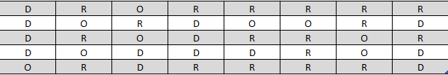

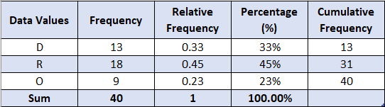

## Organizing Quantitative Data (Homework)

Q. Construct a Frequency Distribution of data given below.

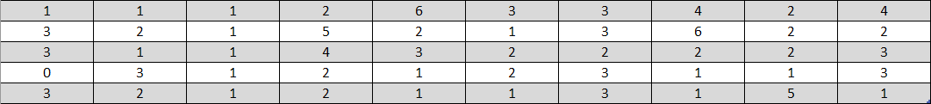

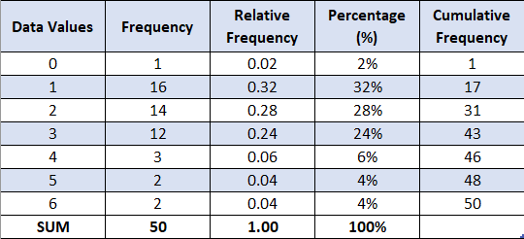

## ORGANIZING QUANTITATIVE DATA (Grouped)

Q. Construct a Frequency Distribution of data given below.

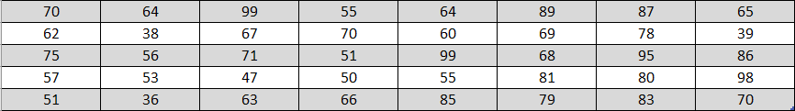

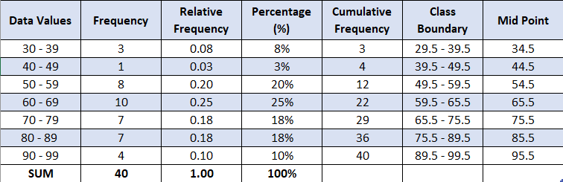

Q. Construct a Frequency Distribution of data given below.

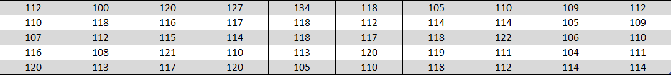

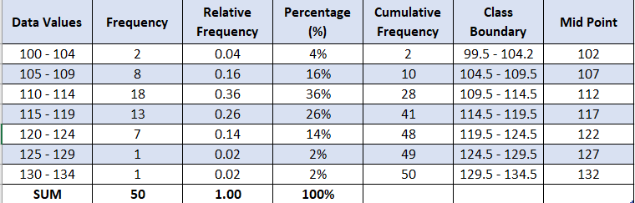

# Graphical Representation

Using the Frequency Table above for example.

## Pie Chart

Pie chart shows how large each category is in relation to the whole.

It uses relative frequencies to divide the pie, into different-sized wedges.

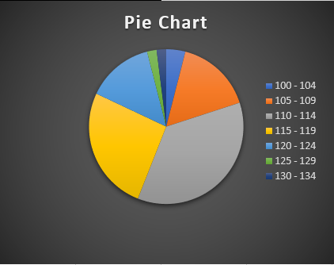

## Histogram

Histograms are same as bar charts, but used for grouped data, and the bars should be in touch.

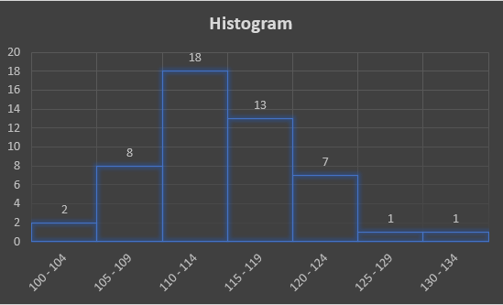**Frequency Histogram:**

Y-Axis 🡪 Frequency.

X-Axis 🡪 Class Boundary.

**Rel-Frequency Histogram:**

Y-Axis 🡪 Rel-Frequency.

X-Axis 🡪 Class Boundary.

### Distribution Shapes

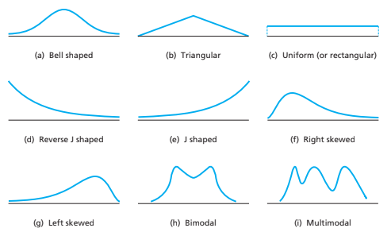

## Line Graph

A line graph is used when data are measured over time.

The X-Axis represents times, and the Y-Axis represents the variable being measured.

**Here for the sake of example we will take Midpoints instead of time.**

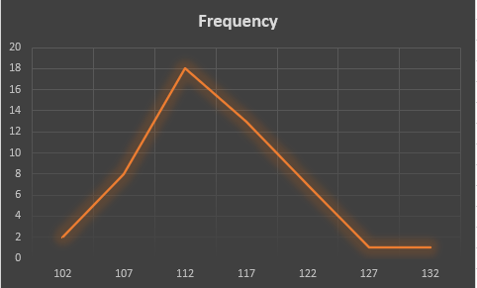

### POLYGONS

**Frequency Polygon:**

Y-Axis 🡪 Frequency.

X-Axis 🡪 Mid-Point.

**Relative Frequency Polygon:**

Y-Axis 🡪 Relative Frequency.

X-Axis 🡪 Mid-Point.

### OGIVE

Y-Axis 🡪 Cumulative Frequency.

X-Axis 🡪 Class Boundary.

Point 0 = First Lower Limit of class boundary.

### Stem and Leaf Plot

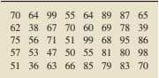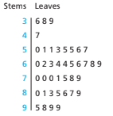

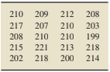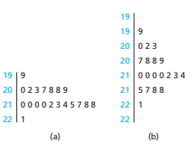

# Mean, Mode, & Median

## Mean

### The Sample Mean

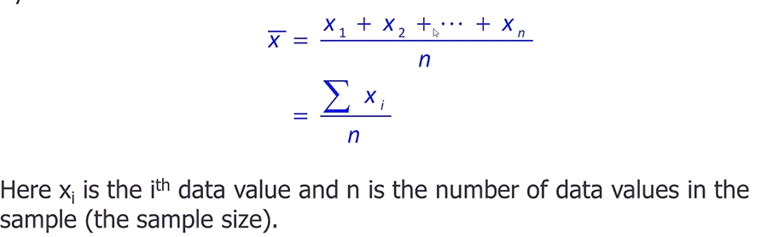

Example: 5, 6, 8, 10, 4, 6, 9

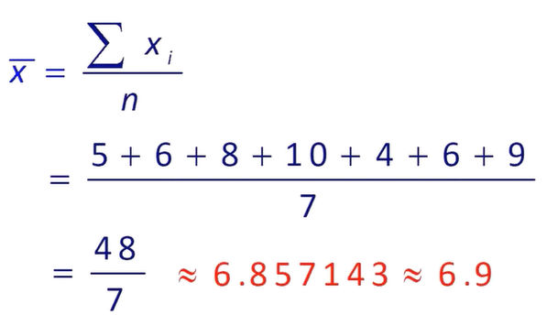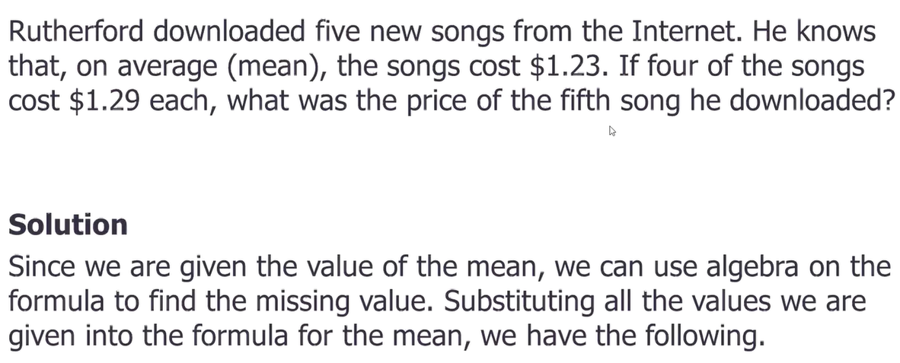

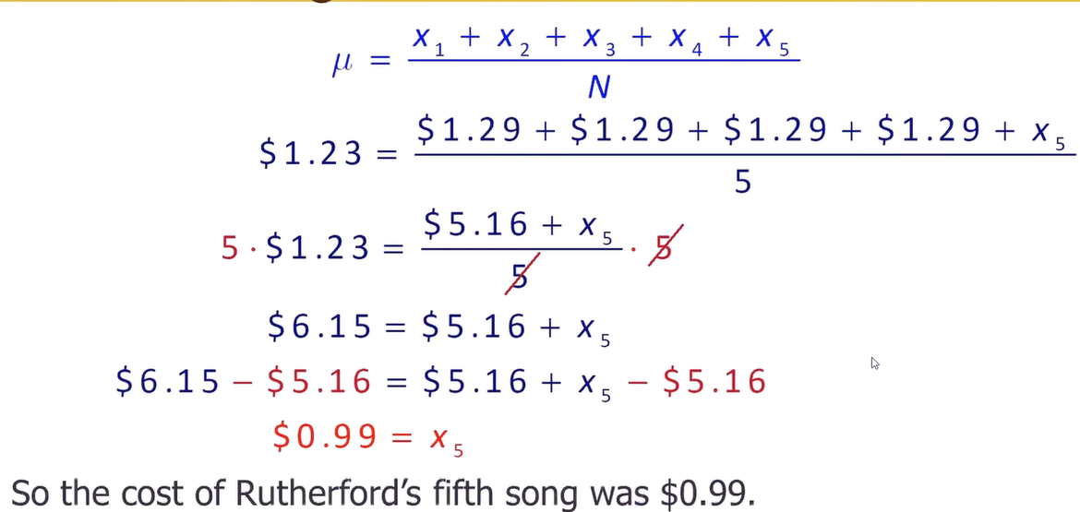

### Population Mean

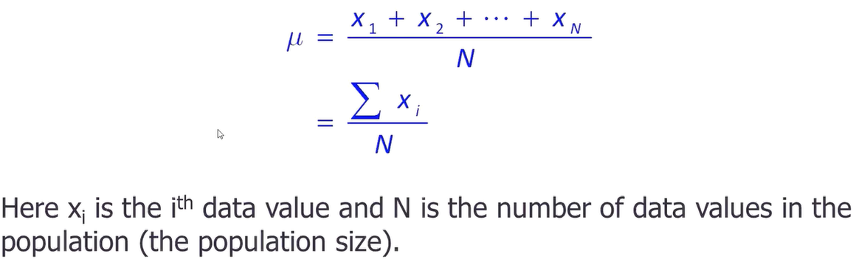

## Median

Median is the “Middle Value” in the sense that about half of the data is above it and about half of the data is below it.

Calculating the median of a data set:

1. List the data in ascending order.
2. If the n is odd, the median is the middle value.
3. If the n is even, the median is the arithmetic mean of two middle values.

**Example:**

1. 3, 4, 6, 7, 2, 8, 9

2, 3, 4, **6**, 7, 8, 9

6 is the Median.

1. 5, 7, 8, 1, 4, 9, 8, 9

1, 4, 5, **7**, **8**, 8, 9, 9

7+8/2

7.5 is the Median.

## Mode

Mode is the most observed value.

1. Unimodal: One value occurs the most.
2. Bimodal: Exactly two values occur equally often.
3. Multimodal: More than two values occur equally often.

If the data values occur once or same number of times each, we say there is no mode.

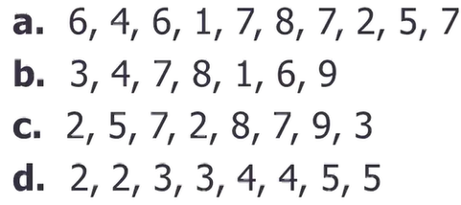

1. 7
2. no mode.
3. 7 and 2
4. no mode.

## Example

Calculate Mean, Mode and Median for the given data.

1. 84, 80, 82, 77, 78, 80, 79, 42

Mean: 75.25

Mode: 80

Median: 77.5

## Range

Range = Max Value – Min Value

## Sample Variance

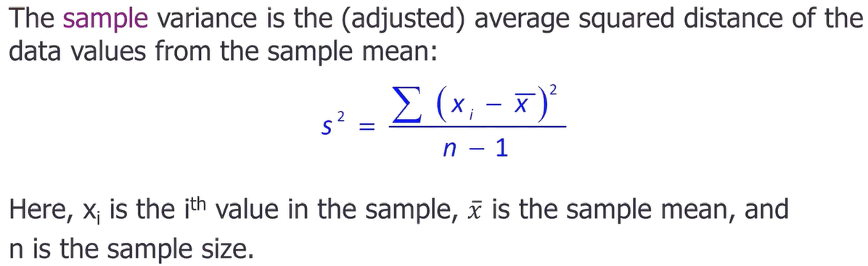

## Population Variance

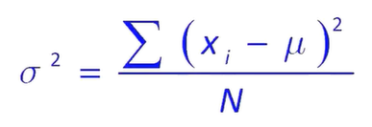



**Example:**

**Data:** 3, 2, 5, 6, 4

1. Assume that the data represents the actual weight changes for a sample of fitness club members during the month of April.
2. Assume that the data represents the actual weight changes of every member of a book club during the month of April.

### A)

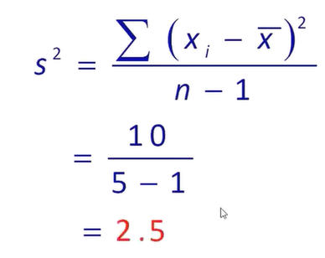

## Standard Deviation

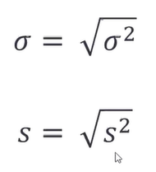

# Measures of Relative Position

## Percentiles

Diving data into 100 parts, the divisions are called percentiles.

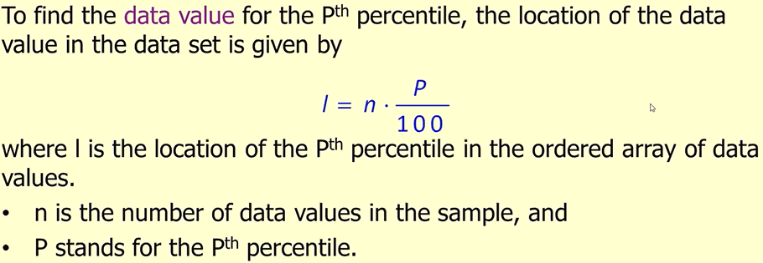

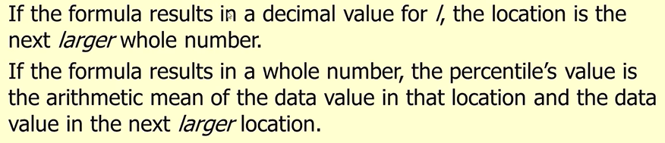

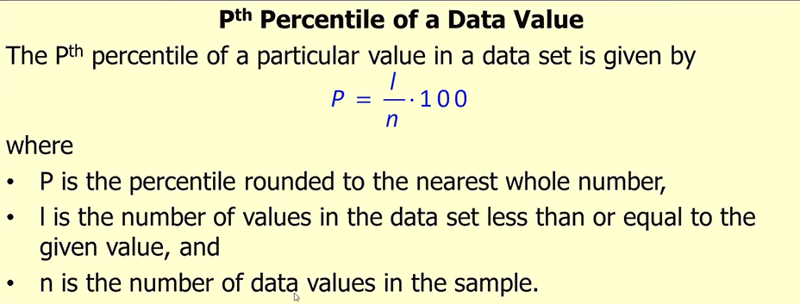

## Quartiles

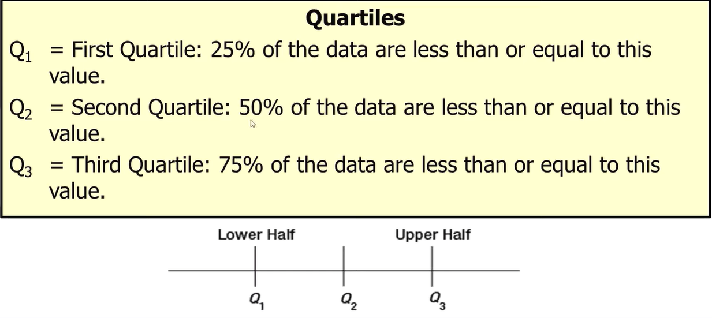

### Formula

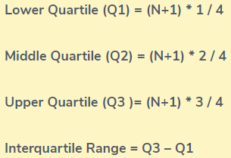

**Example:**





**Grouped Data:**

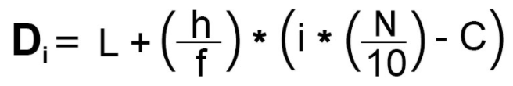

## Deciles

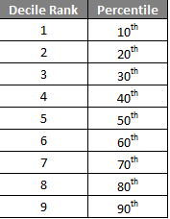



**For Grouped Data:**



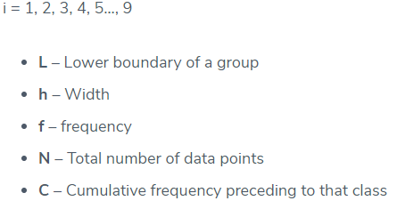

## Box – Plot

